BASOTHO TOMBSTONE COVER AGENT WORKSHOP

“DIGNIFIED REMEMBRANCE ALWAYS”

WORKSHOP

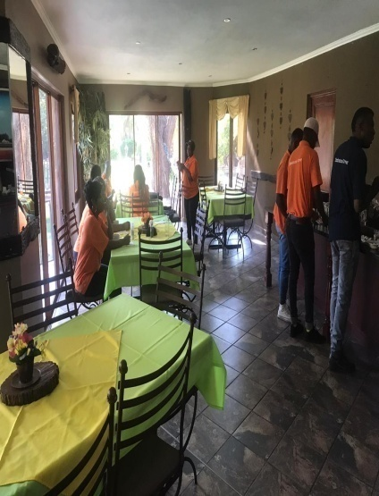
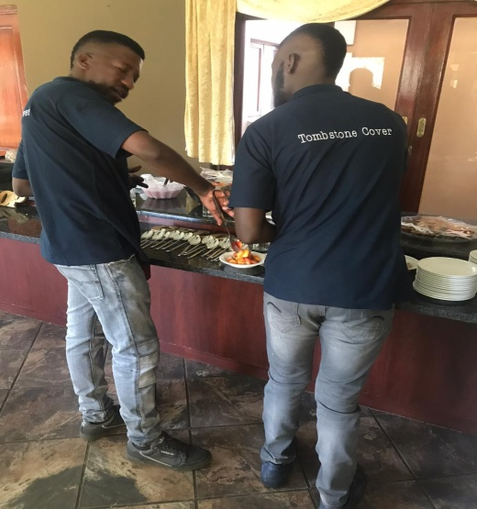
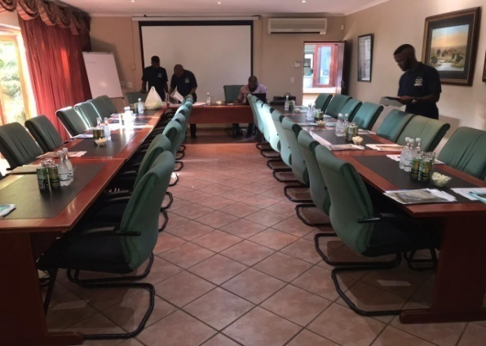
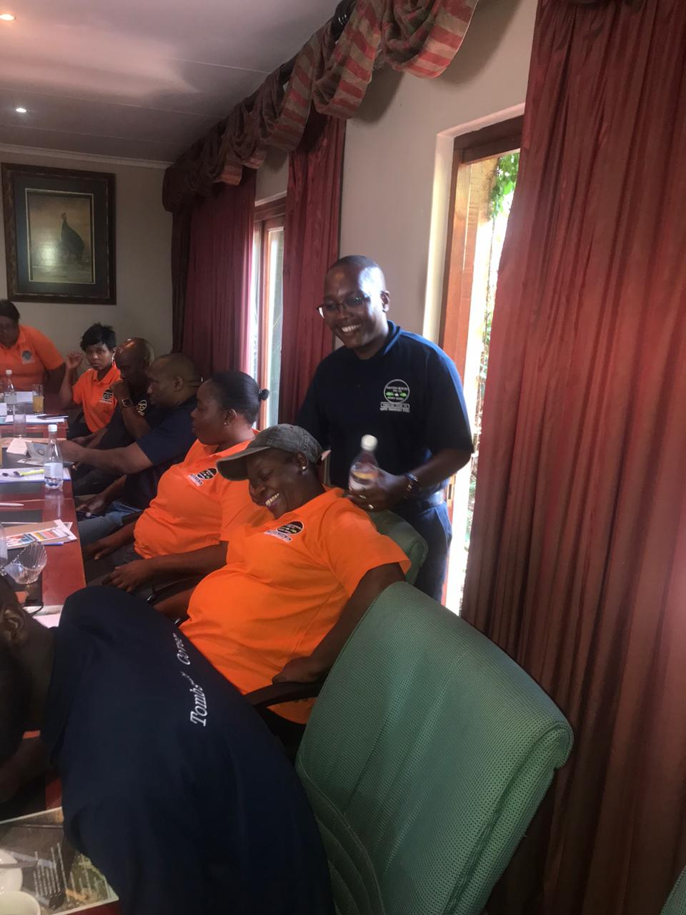
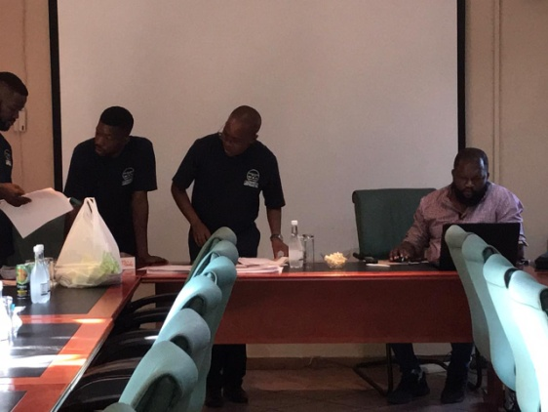
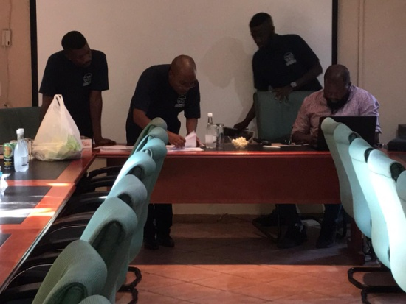
SUCCESFUL BTC WORKSHOP AGENTS FROM GAUTENG AND THE NORTH WEST PROVINCE

